Index :
<!DOCTYPE html>
<html lang="en">
<head>
<meta charset="UTF-8">
<meta name="viewport" content="width=device-width, initial-scale=1.0">
<title>TechFest 2026</title>

<link rel="stylesheet" href="css/style.css">
</head>

<body>

<header>

<div class="logo">
<h1>TechFest 2026</h1>
</div>

<nav>

<ul>

<li><a href="index.html" class="active">Home</a></li>

<li><a href="events.html">Events</a></li>

<li><a href="gallery.html">Gallery</a></li>

<li><a href="register.html">Register</a></li>

<li><a href="contact.html">Contact</a></li>

</ul>

</nav>

</header>

<!-- Hero Banner -->

<section class="hero">

<div class="overlay">

<h2>Welcome to TechFest 2026</h2>

<p>
Innovation • Technology • Creativity
</p>

<a href="register.html" class="btn">Register Now</a>

</div>

</section>

<!-- About -->

<section class="about">

<h2>About TechFest</h2>

<p>

TechFest 2026 is a national-level technical festival bringing together students, innovators, developers and technology enthusiasts for competitions, workshops, hackathons and exhibitions.

</p>

</section>

<!-- Events -->

<section class="events">

<h2>Featured Events</h2>

<div class="cards">

<div class="card">

<img src="images/coding.png">

<h3>Coding Challenge</h3>

<p>Compete with the best programmers.</p>

</div>

<div class="card">

<img src="images/robotics.png">

<h3>Robotics</h3>

<p>Build and battle intelligent robots.</p>

</div>

<div class="card">

<img src="images/ai.png">

<h3>AI Workshop</h3>

<p>Learn Machine Learning & AI.</p>

</div>

<div class="card">

<img src="images/cyber.png">

<h3>Cyber Security</h3>

<p>Hands-on Ethical Hacking Workshop.</p>

</div>

</div>

</section>

<!-- Schedule -->

<section class="schedule">

<h2>Event Schedule</h2>

<table>

<tr>

<th>Time</th>

<th>Event</th>

<th>Venue</th>

</tr>

<tr>

<td>9:00 AM</td>

<td>Opening Ceremony</td>

<td>Main Auditorium</td>

</tr>

<tr>

<td>10:30 AM</td>

<td>Coding Contest</td>

<td>Lab 1</td>

</tr>

<tr>

<td>12:00 PM</td>

<td>Robotics Competition</td>

<td>Hall A</td>

</tr>

<tr>

<td>2:00 PM</td>

<td>AI Workshop</td>

<td>Seminar Hall</td>

</tr>

<tr>

<td>4:00 PM</td>

<td>Prize Distribution</td>

<td>Auditorium</td>

</tr>

</table>

</section>

<!-- Gallery -->

<section class="gallery">

<h2>Gallery Preview</h2>

<div class="gallery-grid">

<img src="images/gallery1.png">

<img src="images/gallery2.png">

<img src="images/gallery3.png">

<img src="images/gallery4.png">

</div>

</section>

<section class="contact">

<h2>Contact Us</h2>

<p>Email : techfest2026@gmail.com</p>

<p>Phone : +91 9876543210</p>

<p>Location : ABC Engineering College</p>

</section>

<footer>

<p>© 2026 TechFest. All Rights Reserved.</p>

</footer>

</body>
</html>
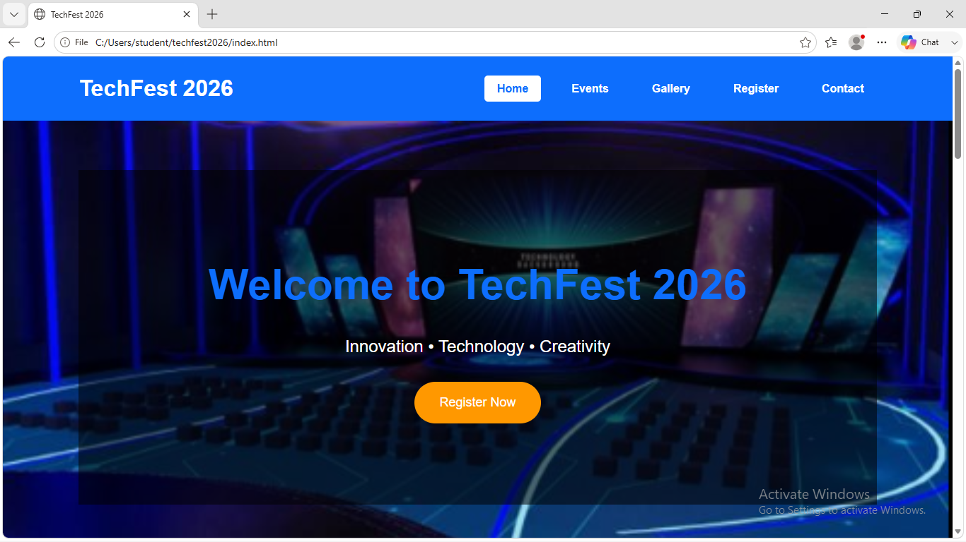
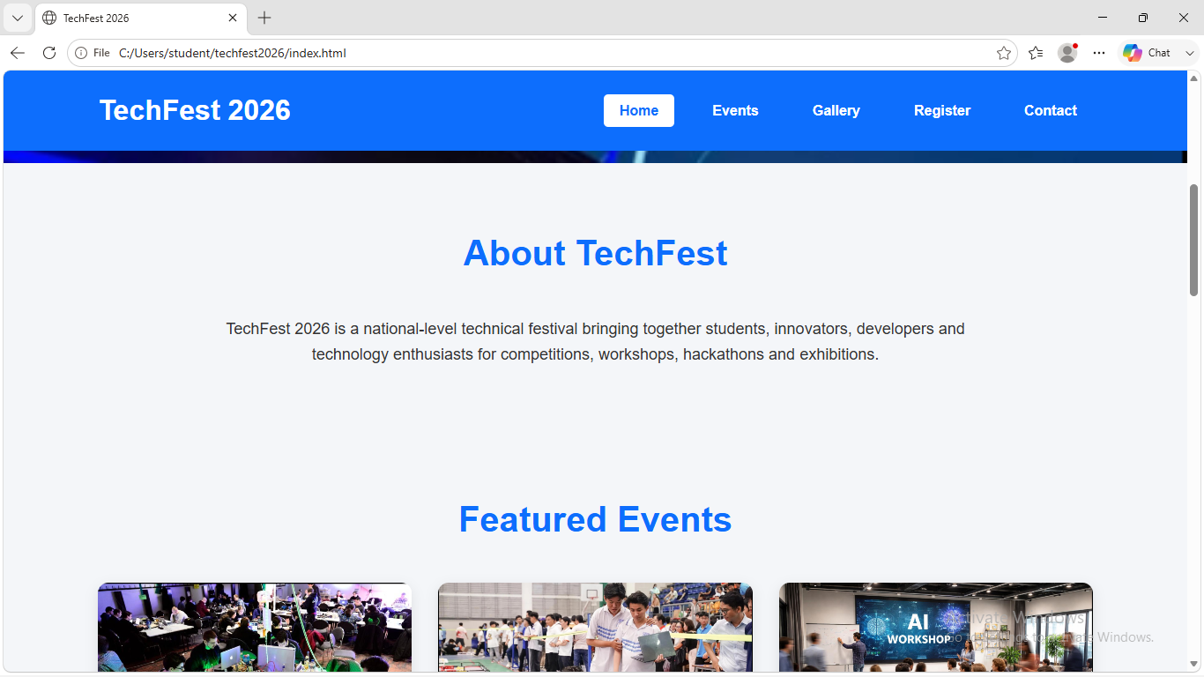
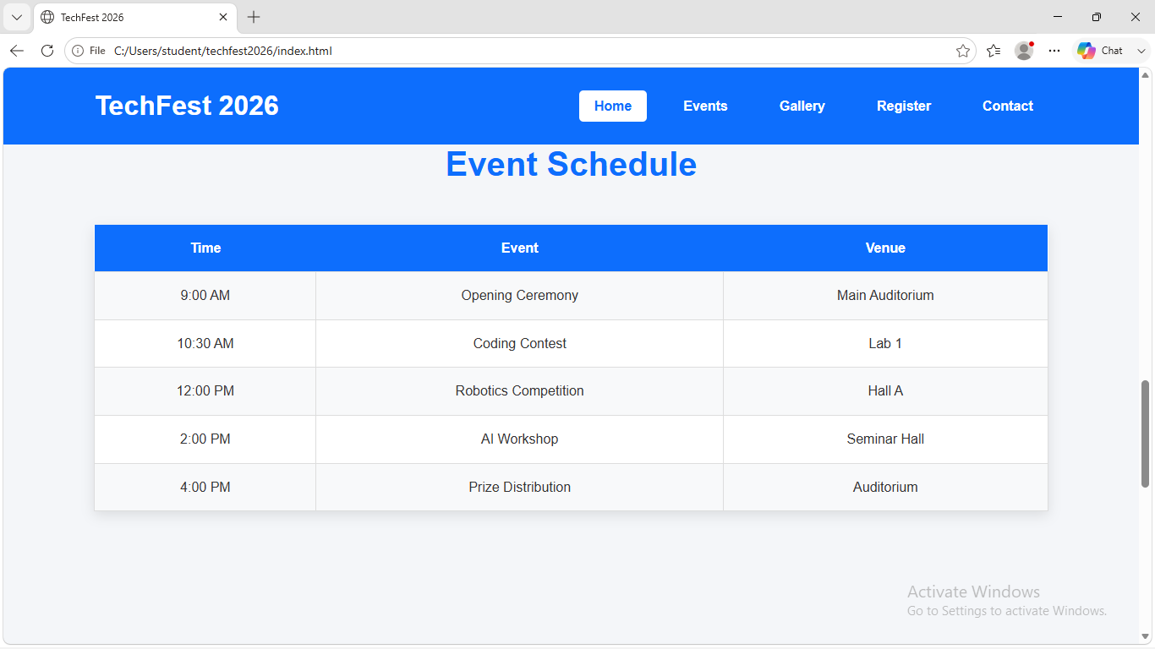
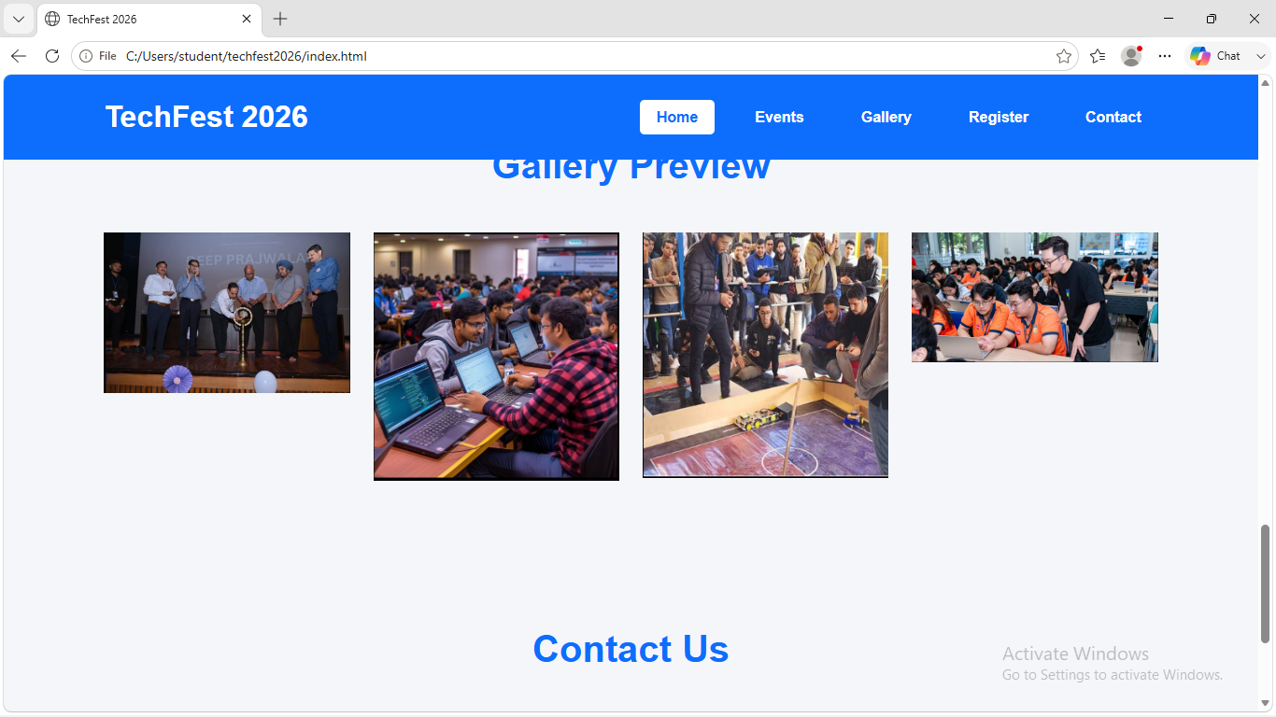
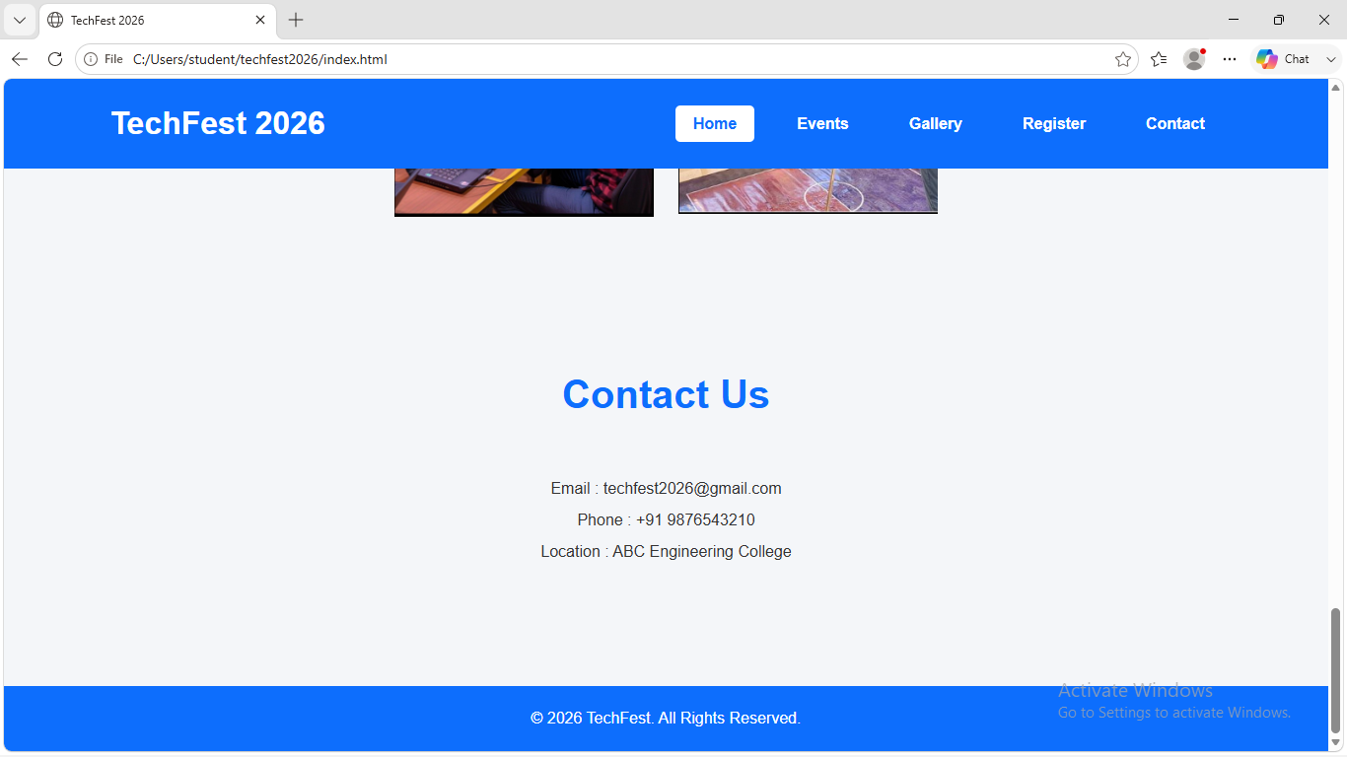
Events :
<!DOCTYPE html>
<html lang="en">
<head>
<meta charset="UTF-8">
<meta name="viewport" content="width=device-width, initial-scale=1.0">

<title>TechFest 2026 | Events</title>

<link rel="stylesheet" href="css/style.css">
</head>

<body>

<header>

<div class="logo">
<h1>TechFest 2026</h1>
</div>

<nav>
<ul>
<li><a href="index.html">Home</a></li>
<li><a href="events.html" class="active">Events</a></li>
<li><a href="gallery.html">Gallery</a></li>
<li><a href="register.html">Register</a></li>
<li><a href="contact.html">Contact</a></li>
</ul>
</nav>

</header>

<!-- Banner -->

<section class="page-banner">

<h2>Our Events</h2>

<p>Explore exciting competitions, workshops and technical challenges.</p>

</section>

<!-- Event Cards -->

<section class="events">

<h2>Featured Events</h2>

<div class="cards">

<div class="card">

<img src="images/coding.png" alt="Coding">

<h3>Coding Challenge</h3>

<p>
Test your programming skills by solving algorithmic problems within a limited time.
</p>

<p><strong>Date:</strong> 15 March 2026</p>

<p><strong>Time:</strong> 10:00 AM</p>

<p><strong>Venue:</strong> Computer Lab 1</p>

</div>

<div class="card">

<img src="images/robotics.png" alt="Robotics">

<h3>Robotics Competition</h3>

<p>
Design and compete with autonomous robots to complete exciting tasks.
</p>

<p><strong>Date:</strong> 15 March 2026</p>

<p><strong>Time:</strong> 12:00 PM</p>

<p><strong>Venue:</strong> Robotics Arena</p>

</div>

<div class="card">

<img src="images/ai.png" alt="AI Workshop">

<h3>AI & Machine Learning Workshop</h3>

<p>
Learn Artificial Intelligence, Machine Learning and Deep Learning from experts.
</p>

<p><strong>Date:</strong> 16 March 2026</p>

<p><strong>Time:</strong> 10:00 AM</p>

<p><strong>Venue:</strong> Seminar Hall</p>

</div>

<div class="card">

<img src="images/cyber.png" alt="Cyber Security">

<h3>Cyber Security Workshop</h3>

<p>
Experience ethical hacking demonstrations and learn how to secure systems.
</p>

<p><strong>Date:</strong> 16 March 2026</p>

<p><strong>Time:</strong> 2:00 PM</p>

<p><strong>Venue:</strong> Lab 2</p>

</div>

<div class="card">

<img src="images/24 hrs.png" alt="Hackathon">

<h3>24-Hour Hackathon</h3>

<p>
Build innovative software solutions with your team in an exciting hackathon.
</p>

<p><strong>Date:</strong> 17 March 2026</p>

<p><strong>Time:</strong> 9:00 AM</p>

<p><strong>Venue:</strong> Innovation Hub</p>

</div>

<div class="card">

<img src="images/gallery2.png" alt="Project Expo">

<h3>Project Exhibition</h3>

<p>
Showcase your innovative engineering and software projects to judges and visitors.
</p>

<p><strong>Date:</strong> 17 March 2026</p>

<p><strong>Time:</strong> 11:00 AM</p>

<p><strong>Venue:</strong> Exhibition Hall</p>

</div>

</div>

</section>

<footer>

<p>© 2026 TechFest | All Rights Reserved</p>

</footer>

</body>
</html>
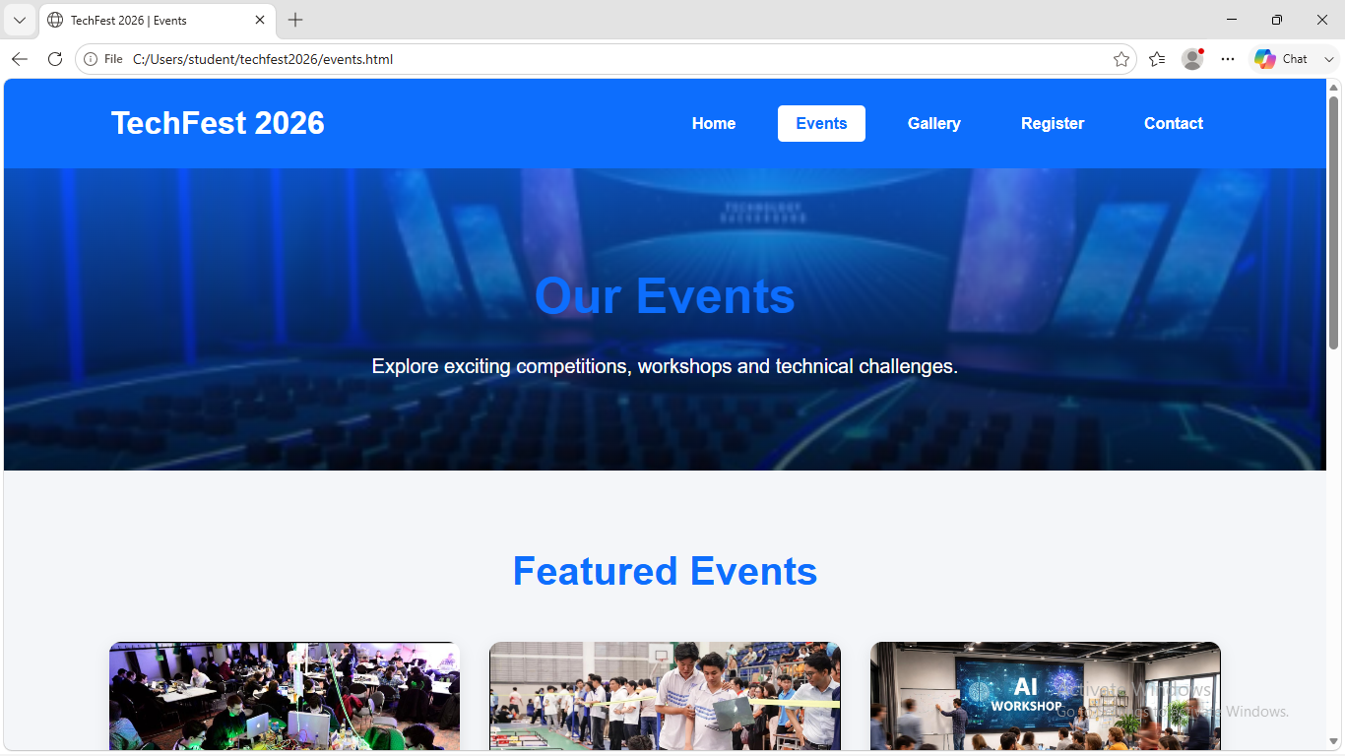
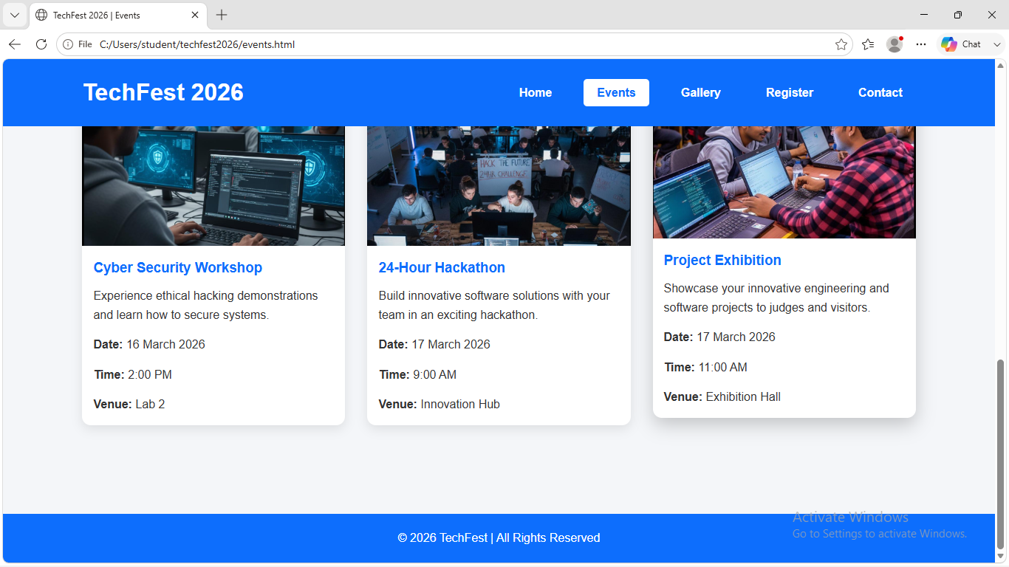

Register :

<!DOCTYPE html>
<html lang="en">
<head>
<meta charset="UTF-8">
<meta name="viewport" content="width=device-width, initial-scale=1.0">
<title>TECHFEST 2026 Registration</title>
<link rel="stylesheet" href="css/style.css">
<style>
.valid-input { border: 2px solid #28a745; outline: none; }
.invalid-input { border: 2px solid #dc3545; outline: none; }
.error-msg { color: #dc3545; font-size: 0.85em; display: block; margin-bottom: 5px; }
</style>
</head>
<body>
<div align="center">
<h1>TECHFEST 2026</h1>
<img src="./image/d.png" width="200" height="100" alt="Techfest Logo"/>
<nav>
<ul>
<li><a href="index.html">Home</a></li>
<li><a href="events.html">Events</a></li>
<li><a href="register.html">Register</a></li>
<li><a href="gallery.html">Gallery</a></li>
<li><a href="contact.html">Contact</a></li>
</ul>
</nav>
</div>

<form id="registrationForm" style="margin-top: 20px;" novalidate>
<label for="name">Name: </label>
<input type="text" id="name">
<span class="error-msg" id="nameError"></span>

<label for="email">Email: </label>
<input type="text" id="email">
<span class="error-msg" id="emailError"></span>

<label for="phone">Phone: </label>
<input type="text" id="phone">
<span class="error-msg" id="phoneError"></span>

<label for="dob">DOB: </label>
<input type="date" id="dob">
<span class="error-msg" id="dobError"></span>

<label>Gender: </label>
<input type="radio" id="male" name="gender" value="Male">
<label for="male">Male</label>
<input type="radio" id="female" name="gender" value="Female">
<label for="female">Female</label>
<span class="error-msg" id="genderError"></span><br>

<label>Events: </label>
<input type="checkbox" name="events" value="Workshop"> <label>Workshop</label>
<input type="checkbox" name="events" value="Competitions"> <label>Competitions</label>
<input type="checkbox" name="events" value="Games"> <label>Games</label>
<input type="checkbox" name="events" value="Musical Event"> <label>Musical Event</label>
<span class="error-msg" id="eventsError"></span><br>

<label for="department">Department: </label>
<select id="department">
<option value="">--Select Department--</option>
<option value="CSE">CSE</option>
<option value="ECE">ECE</option>
<option value="EEE">EEE</option>
<option value="CE">CE</option>
<option value="ME">ME</option>
</select>
<span class="error-msg" id="deptError"></span><br>

<label for="message">Message</label><br>
<textarea id="message" rows="6" cols="50" maxlength="500"></textarea><br>

<button type="submit">Submit</button>
</form>

<footer>
&copy;2026 Developed by laya
</footer>
<script defer src="js/app.js"></script>
</body>
</html>

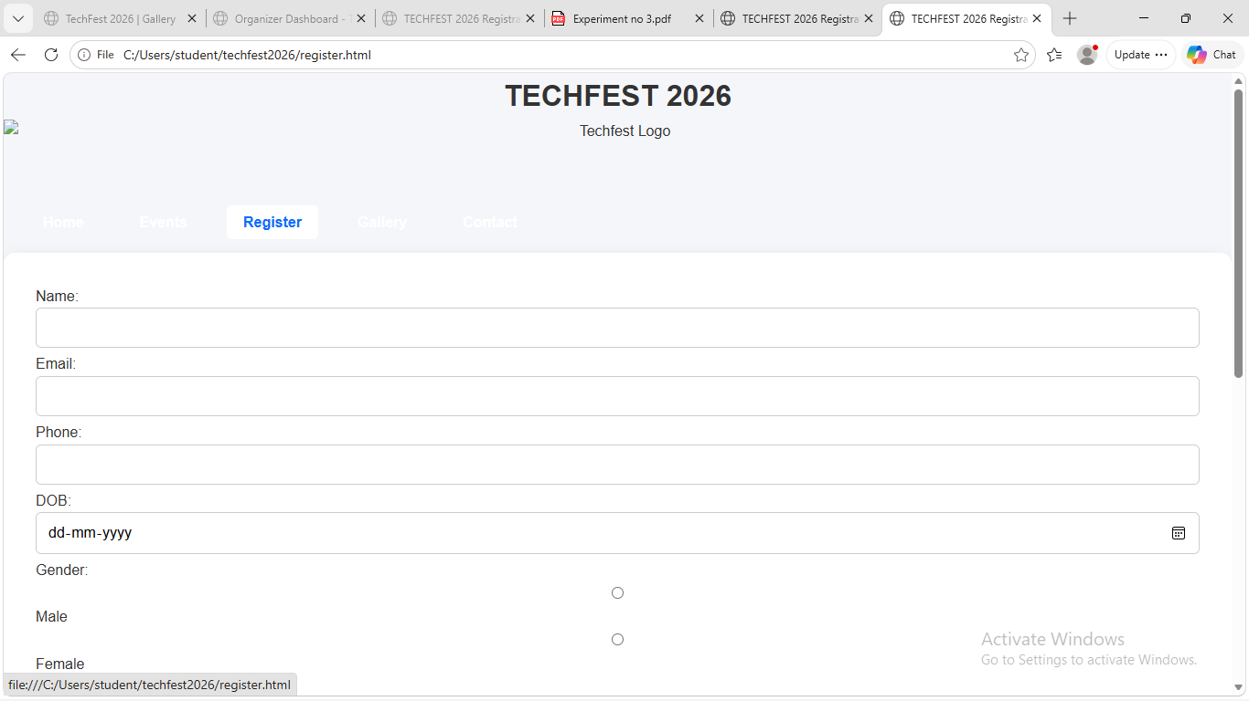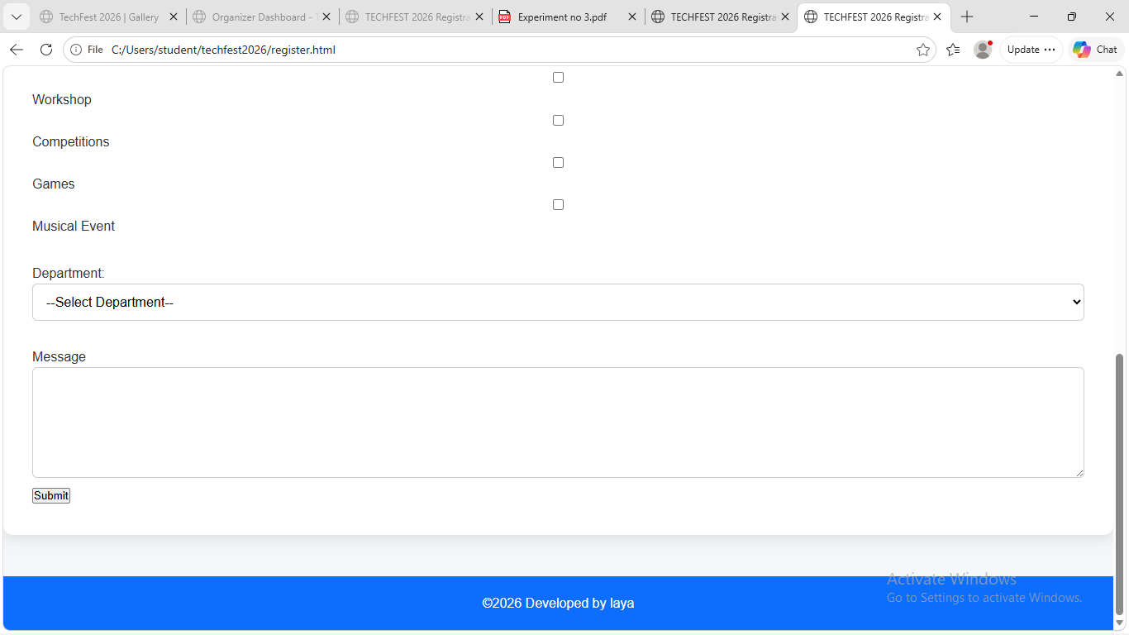

Gallery:
<!DOCTYPE html>
<html lang="en">
<head>
<meta charset="UTF-8">
<meta name="viewport" content="width=device-width, initial-scale=1.0">
<title>TechFest 2026 | Gallery</title>
<link rel="stylesheet" href="css/style.css">
</head>
<body>

<header>

<div class="logo">
<h1>TechFest 2026</h1>
</div>

<nav>
<ul>
<li><a href="index.html">Home</a></li>
<li><a href="events.html">Events</a></li>
<li><a href="register.html">Register</a></li>
<li><a href="gallery.html" class="active">Gallery</a></li>
<li><a href="contact.html">Contact</a></li>
</ul>
</nav>

</header>

<section class="page-banner">
<h2>Gallery</h2>
<p>Highlights from TechFest 2026</p>
</section>

<section class="gallery">

<h2>Event Gallery</h2>

<div class="gallery-grid">

<div class="gallery-item">
<img src="images/coding.png" alt="Coding Challenge">
<h3>Coding Challenge</h3>
</div>

<div class="gallery-item">
<img src="images/gallery2.png" alt="Robotics">
<h3>Robotics Competition</h3>
</div>

<div class="gallery-item">
<img src="images/ai.png" alt="AI Workshop">
<h3>AI Workshop</h3>
</div>

<div class="gallery-item">
<img src="images/gallery4.png" alt="Cyber Security">
<h3>Cyber Security Workshop</h3>
</div>

<div class="gallery-item">
<img src="images/gallery1.png" alt="Opening Ceremony">
<h3>Opening Ceremony</h3>
</div>

<div class="gallery-item">
<img src="images/24 hrs.png" alt="Hackathon">
<h3>24-Hour Hackathon</h3>
</div>

<div class="gallery-item">
<img src="images/gallery3.png" alt="Project Expo">
<h3>Project Exhibition</h3>
</div>

<div class="gallery-item">
<img src="images/prize.png" alt="Prize Distribution">
<h3>Prize Distribution</h3>
</div>

</div>

</section>

<footer>
<p>© 2026 TechFest | All Rights Reserved</p>
</footer>

</body>
</html>

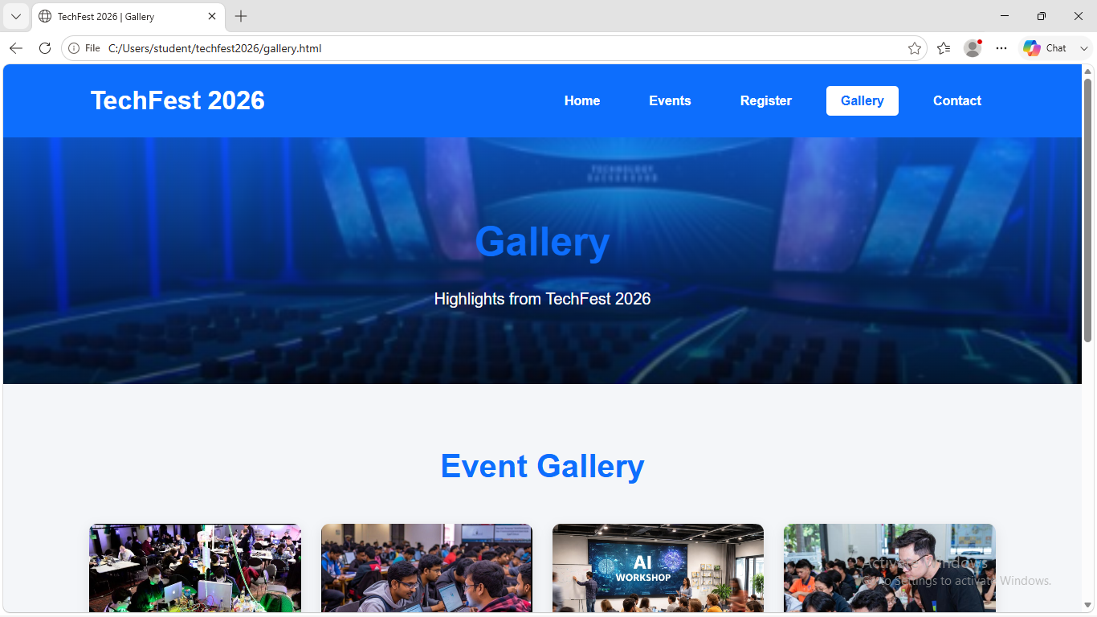
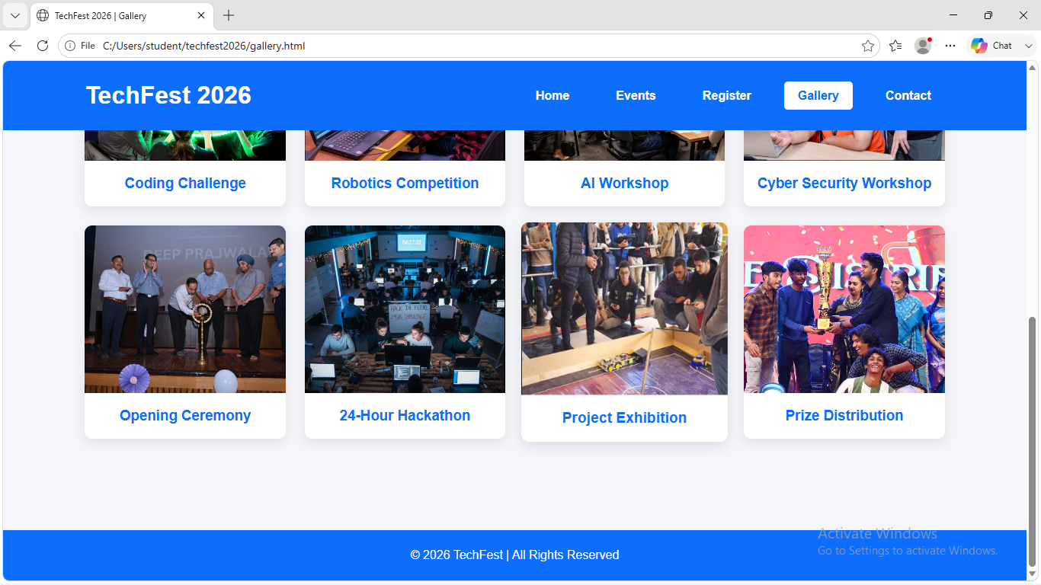

Contact:
<!DOCTYPE html>
<html lang="en">
<head>
<meta charset="UTF-8">
<meta name="viewport" content="width=device-width, initial-scale=1.0">
<title>TechFest 2026 | Contact</title>

<link rel="stylesheet" href="css/style.css">
</head>
<body>

<header>

<div class="logo">
<h1>TechFest 2026</h1>
</div>

<nav>
<ul>
<li><a href="index.html">Home</a></li>
<li><a href="events.html">Events</a></li>
<li><a href="register.html">Register</a></li>
<li><a href="gallery.html">Gallery</a></li>
<li><a href="contact.html" class="active">Contact</a></li>
</ul>
</nav>

</header>

<section class="page-banner">
<h2>Contact Us</h2>
<p>We're here to help. Get in touch with the TechFest Team.</p>
</section>

<section class="contact-container">

<div class="contact-info">

<h2>Get in Touch</h2>

<p>
We'd love to hear from you! Feel free to contact us for event
registration, sponsorship opportunities, or general inquiries.
</p>

<h3>📍 Address</h3>
<p>ABC Engineering College, Kochi, Kerala</p>

<h3>📧 Email</h3>
<p>techfest2026@gmail.com</p>

<h3>📞 Phone</h3>
<p>+91 9876543210</p>

<h3>🌐 Website</h3>
<p>www.techfest2026.com</p>

</div>

<div class="contact-form">

<h2>Send a Message</h2>

<form>

<input type="text"
placeholder="Your Name"
required>

<input type="email"
placeholder="Your Email"
required>

<input type="text"
placeholder="Subject"
required>

<textarea rows="6"
placeholder="Your Message"
required></textarea>

<button class="btn">
Send Message
</button>

</form>

</div>

</section>

<footer>

<p>© 2026 TechFest | All Rights Reserved</p>

</footer>

</body>
</html>

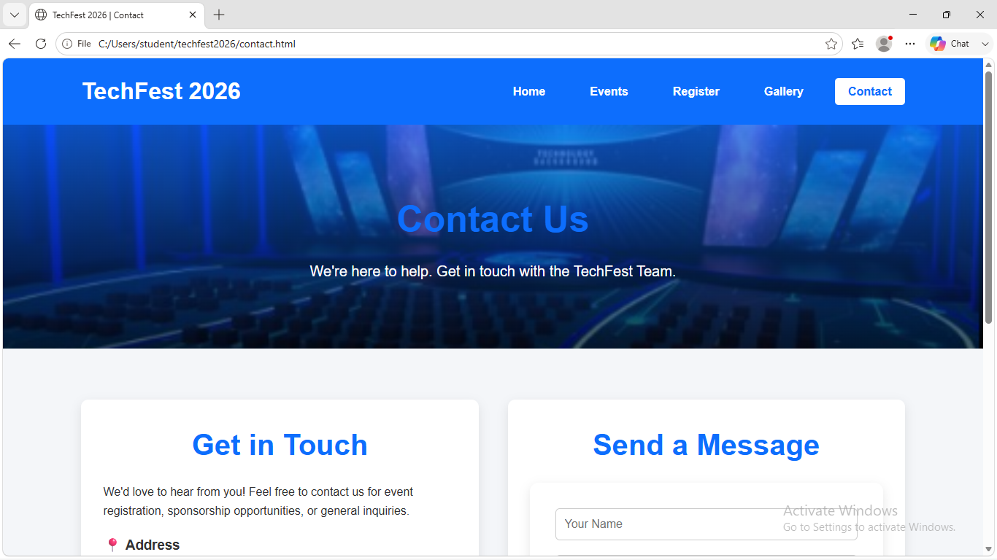
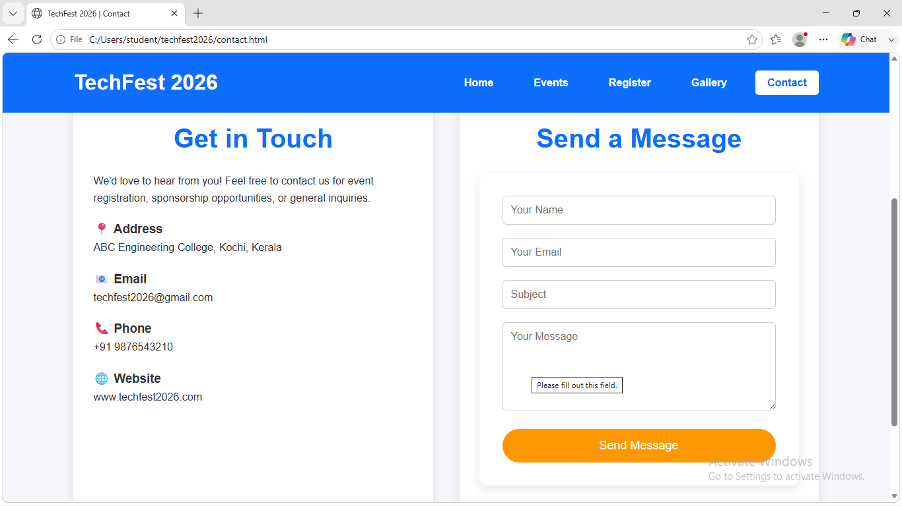

CSS:

*{
margin:0;
padding:0;
box-sizing:border-box;
font-family:Arial, Helvetica, sans-serif;
}

body{
background:#f4f6f9;
color:#333;
line-height:1.6;
}

img{
width:100%;
display:block;
}

a{
text-decoration:none;
}

header{
background:#0d6efd;
display:flex;
justify-content:space-between;
align-items:center;
padding:20px 8%;
position:sticky;
top:0;
z-index:1000;
}

.logo h1{
color:white;
}

nav ul{
display:flex;
list-style:none;
}

nav ul li{
margin-left:25px;
}

nav ul li a{
color:white;
font-weight:bold;
padding:10px 18px;
transition:.3s;
}

nav ul li a:hover{
background:white;
color:#0d6efd;
border-radius:5px;
}

.active{
background:white;
color:#0d6efd !important;
border-radius:5px;
}

.hero{
height:90vh;
background:url("../images/banner.png") center/cover no-repeat;
}

.overlay{
width:100%;
height:100%;
background:rgba(0,0,0,.55);
display:flex;
flex-direction:column;
justify-content:center;
align-items:center;
color:white;
text-align:center;
}

.overlay h2{
font-size:60px;
margin-bottom:20px;
}

.overlay p{
font-size:24px;
margin-bottom:30px;
}

.btn{
background:#ff9800;
color:white;
padding:15px 35px;
border-radius:40px;
font-size:18px;
display:inline-block;
transition:.3s;
}

.btn:hover{
background:white;
color:#ff9800;
}

.page-banner{
background:linear-gradient(rgba(13,110,253,.7),rgba(0,0,0,.6)),
url("../images/banner.png");
background-size:cover;
background-position:center;
color:white;
text-align:center;
padding:90px 20px;
}

.page-banner h2{
font-size:50px;
margin-bottom:15px;
}

.page-banner p{
font-size:20px;
}

section{
padding:70px 8%;
}

section h2{
text-align:center;
margin-bottom:40px;
color:#0d6efd;
font-size:40px;
}

.about p{
max-width:900px;
margin:auto;
text-align:center;
font-size:18px;
}

.cards{
display:grid;
grid-template-columns:repeat(auto-fit,minmax(280px,1fr));
gap:30px;
margin-top:30px;
}

.card{
background:#fff;
border-radius:12px;
overflow:hidden;
box-shadow:0 5px 15px rgba(0,0,0,0.1);
transition:0.3s;
}

.card:hover{
transform:translateY(-10px);
box-shadow:0 10px 25px rgba(0,0,0,0.2);
}

.card img{
width:100%;
height:220px;
object-fit:cover;
}

.card h3{
color:#0d6efd;
padding:15px 15px 10px;
}

.card p{
padding:0 15px 15px;
line-height:1.6;
}

table{
width:100%;
border-collapse:collapse;
background:#fff;
box-shadow:0 5px 15px rgba(0,0,0,0.1);
}

table th{
background:#0d6efd;
color:#fff;
padding:15px;
}

table td{
padding:15px;
text-align:center;
border:1px solid #ddd;
}

table tr:nth-child(even){
background:#f8f9fa;
}

.gallery-grid{
display:grid;
grid-template-columns:repeat(auto-fit,minmax(250px,1fr));
gap:25px;
}

.gallery-item{
background:#fff;
border-radius:10px;
overflow:hidden;
text-align:center;
box-shadow:0 5px 15px rgba(0,0,0,.1);
transition:.3s;
}

.gallery-item:hover{
transform:scale(1.03);
}

.gallery-item img{
height:220px;
object-fit:cover;
}

.gallery-item h3{
padding:15px;
color:#0d6efd;
}

.register{
max-width:700px;
margin:auto;
}

form{
background:#fff;
padding:35px;
border-radius:12px;
box-shadow:0 5px 15px rgba(0,0,0,.1);
}

.form-group{
margin-bottom:20px;
}

.form-group label{
display:block;
margin-bottom:8px;
font-weight:bold;
}

input,
select,
textarea{
width:100%;
padding:12px;
border:1px solid #ccc;
border-radius:6px;
font-size:16px;
}

textarea{
resize:vertical;
}

button.btn{
border:none;
cursor:pointer;
width:100%;
}

.contact-container{
display:grid;
grid-template-columns:1fr 1fr;
gap:40px;
}

.contact-info{
background:#fff;
padding:30px;
border-radius:10px;
box-shadow:0 5px 15px rgba(0,0,0,.1);
}

.contact-info h2,
.contact-form h2{
color:#0d6efd;
margin-bottom:20px;
}

.contact-info h3{
margin-top:20px;
}

.contact-form{
background:#fff;
padding:30px;
border-radius:10px;
box-shadow:0 5px 15px rgba(0,0,0,.1);
}

.contact-form input,
.contact-form textarea{
margin-bottom:20px;
}

.contact{
text-align:center;
line-height:2;
}

footer{
background:#0d6efd;
color:#fff;
text-align:center;
padding:20px;
margin-top:50px;
}

@media(max-width:992px){

header{
flex-direction:column;
}

nav ul{
margin-top:20px;
flex-wrap:wrap;
justify-content:center;
}

.contact-container{
grid-template-columns:1fr;
}

}

@media(max-width:768px){

.overlay h2{
font-size:40px;
}

.overlay p{
font-size:18px;
}

.page-banner h2{
font-size:36px;
}

section h2{
font-size:32px;
}

.cards{
grid-template-columns:1fr;
}

.gallery-grid{
grid-template-columns:1fr;
}

table{
display:block;
overflow-x:auto;
}

}

@media(max-width:500px){

header{
padding:15px;
}

nav ul{
flex-direction:column;
align-items:center;
}

nav ul li{
margin:10px 0;
}

.overlay h2{
font-size:30px;
}

.overlay p{
font-size:16px;
}

.btn{
padding:12px 25px;
font-size:16px;
}

form{
padding:20px;
}

}
App.js
document.addEventListener("DOMContentLoaded", function () {
const regForm = document.getElementById("registrationForm");
const regTable = document.getElementById("registrationTable");
const welcomeMsg = document.getElementById("welcomeMsg");
if (welcomeMsg) {
let visitorName = sessionStorage.getItem("visitorName");
if (!visitorName) {
visitorName = prompt("Welcome! Please enter your name:") || "Visitor";
sessionStorage.setItem("visitorName", visitorName);
}
welcomeMsg.textContent = `Welcome, ${visitorName}!`;
}
if (regForm) {
const nameInput = document.getElementById("name");
const emailInput = document.getElementById("email");
const phoneInput = document.getElementById("phone");
const dobInput = document.getElementById("dob");
const namePattern = /^[A-Za-z ]{3,30}$/;
const emailPattern = /^[\w\.-]+@[\w-]+\.[a-z]{2,}$/i;
const phonePattern = /^[6-9]\d{9}$/;
const dobPattern = /^(199[5-9]|200[0-8])-(0[1-9]|1[0-2])-(0[1-9]|[12]\d|3[01])$/;
function validateField(input, pattern, errorId, errorMsg) {
const errorElement = document.getElementById(errorId);
if (!pattern.test(input.value.trim())) {
input.classList.add("invalid-input");
input.classList.remove("valid-input");
if (errorElement) errorElement.textContent = errorMsg;
return false;
} else {
input.classList.add("valid-input");
input.classList.remove("invalid-input");
if (errorElement) errorElement.textContent = "";
return true;
}
}
nameInput.addEventListener("input", () => validateField(nameInput, namePattern, "nameError", "3-30 letters allowed."));
emailInput.addEventListener("input", () => validateField(emailInput, emailPattern, "emailError", "Invalid email address."));
phoneInput.addEventListener("input", () => validateField(phoneInput, phonePattern, "phoneError", "Enter a 10-digit number."));
dobInput.addEventListener("change", () => validateField(dobInput, dobPattern, "dobError", "DOB must be between 1995 and 2008."));
regForm.addEventListener("submit", function (e) {
e.preventDefault();
const isNameValid = validateField(nameInput, namePattern, "nameError", "3-30 letters allowed.");
const isEmailValid = validateField(emailInput, emailPattern, "emailError", "Invalid email address.");
const isPhoneValid = validateField(phoneInput, phonePattern, "phoneError", "Enter a 10-digit number.");
const isDobValid = validateField(dobInput, dobPattern, "dobError", "DOB must be between 1995 and 2008.");
const genderElement = document.querySelector('input[name="gender"]:checked');
const genderError = document.getElementById("genderError");
if (!genderElement) {
genderError.textContent = "Please select gender.";
} else {
genderError.textContent = "";
}
const eventElements = document.querySelectorAll('input[name="events"]:checked');
const eventsError = document.getElementById("eventsError");
if (eventElements.length === 0) {
eventsError.textContent = "Select at least one event.";
} else {
eventsError.textContent = "";
}
const department = document.getElementById("department").value;
const deptError = document.getElementById("deptError");
if (department === "") {
deptError.textContent = "Please select a department.";
} else {
deptError.textContent = "";
}
if (!isNameValid || !isEmailValid || !isPhoneValid || !isDobValid || !genderElement || eventElements.length === 0 || department === "") {
return;
}
let events = [];
eventElements.forEach(el => events.push(el.value));
const registration = {
name: nameInput.value.trim(),
email: emailInput.value.trim(),
phone: phoneInput.value.trim(),
dob: dobInput.value,
gender: genderElement.value,
events: events,
department: department,
message: document.getElementById("message").value.trim()
};
let registrations = JSON.parse(localStorage.getItem("registrations")) || [];
registrations.push(registration);
localStorage.setItem("registrations", JSON.stringify(registrations));
regForm.reset();
document.querySelectorAll(".valid-input").forEach(el => el.classList.remove("valid-input"));
alert("Registration Successful!");
});
}
if (regTable) {
displayRegistrations();
const clearBtn = document.getElementById("clearAllBtn");
if (clearBtn) {
clearBtn.addEventListener("click", function () {
if (confirm("Are you sure you want to clear all registrations?")) {
localStorage.removeItem("registrations");
displayRegistrations();
}
});
}
setupTaskManager();
}
});
function displayRegistrations() {
let registrations = JSON.parse(localStorage.getItem("registrations")) || [];
let table = document.getElementById("registrationTable");
let totalCountSpan = document.getElementById("totalCount");
if (!table) return;
table.innerHTML = "";
if (totalCountSpan) totalCountSpan.textContent = registrations.length;
registrations.forEach(function (reg, index) {
let row = document.createElement("tr");
row.innerHTML = `
<td>${index + 1}</td>
<td>${reg.name}</td>
<td>${reg.email}</td>
<td>${reg.phone}</td>
<td>${reg.dob}</td>
<td>${reg.gender}</td>
<td>${reg.events.join(", ")}</td>
<td>${reg.department}</td>
<td>${reg.message}</td>
<td><button onclick="deleteParticipant(${index})">Delete</button></td>
`;
table.appendChild(row);
});
}
function deleteParticipant(index) {
let registrations = JSON.parse(localStorage.getItem("registrations")) || [];
registrations.splice(index, 1);
localStorage.setItem("registrations", JSON.stringify(registrations));
displayRegistrations();
}
function setupTaskManager() {
const taskInput = document.getElementById("taskInput");
const addTaskBtn = document.getElementById("addTaskBtn");
const taskList = document.getElementById("taskList");
if (!addTaskBtn) return;
function renderTasks() {
let tasks = JSON.parse(localStorage.getItem("organizerTasks")) || [];
let taskList = document.getElementById("taskList");
if (!taskList) return;
taskList.innerHTML = "";
tasks.forEach((task, index) => {
let li = document.createElement("li");
li.innerHTML = `
<span class="${task.completed ? 'completed-task' : ''}">${task.text}</span>
<div class="task-buttons">
<button onclick="toggleTask(${index})">✓</button>
<button onclick="deleteTask(${index})">Delete</button>
</div>
`;
taskList.appendChild(li);
});
}
addTaskBtn.addEventListener("click", function () {
let taskText = taskInput.value.trim();
if (taskText === "") return;
let tasks = JSON.parse(localStorage.getItem("organizerTasks")) || [];
tasks.push({ text: taskText, completed: false });
localStorage.setItem("organizerTasks", JSON.stringify(tasks));
taskInput.value = "";
renderTasks();
});
window.toggleTask = function (index) {
let tasks = JSON.parse(localStorage.getItem("organizerTasks")) || [];
tasks[index].completed = !tasks[index].completed;
localStorage.setItem("organizerTasks", JSON.stringify(tasks));
renderTasks();
};
window.deleteTask = function (index) {
let tasks = JSON.parse(localStorage.getItem("organizerTasks")) || [];
tasks.splice(index, 1);
localStorage.setItem("organizerTasks", JSON.stringify(tasks));
renderTasks();
};
renderTasks();
}
// ==========================================
// INTERACTIVE GALLERY & LIGHTBOX SLIDESHOW
// ==========================================
document.addEventListener("DOMContentLoaded", function () {
const galleryImages = document.querySelectorAll(".gallery-img");
const lightbox = document.getElementById("lightbox");
const lightboxImg = document.getElementById("lightboxImg");
const closeBtn = document.getElementById("closeBtn");
const prevBtn = document.getElementById("prevBtn");
const nextBtn = document.getElementById("nextBtn");
const startSlideBtn = document.getElementById("startSlideBtn");
const stopSlideBtn = document.getElementById("stopSlideBtn");

if (!lightbox) return; // Exit if not on gallery page

let currentIndex = 0;
let slideshowInterval = null;

function showImage(index) {
if (index < 0) {
currentIndex = galleryImages.length - 1;
} else if (index >= galleryImages.length) {
currentIndex = 0;
} else {
currentIndex = index;
}
lightboxImg.src = galleryImages[currentIndex].src;
}

function openLightbox(index) {
lightbox.style.display = "flex";
showImage(index);
}

function closeLightbox() {
lightbox.style.display = "none";
stopSlideshow();
}

function startSlideshow() {
if (!slideshowInterval) {
slideshowInterval = setInterval(() => {
showImage(currentIndex + 1);
}, 3000);
}
}

function stopSlideshow() {
if (slideshowInterval) {
clearInterval(slideshowInterval);
slideshowInterval = null;
}
}

galleryImages.forEach((img, idx) => {
img.addEventListener("click", () => openLightbox(idx));
});

closeBtn.addEventListener("click", closeLightbox);
nextBtn.addEventListener("click", () => showImage(currentIndex + 1));
prevBtn.addEventListener("click", () => showImage(currentIndex - 1));
startSlideBtn.addEventListener("click", startSlideshow);
stopSlideBtn.addEventListener("click", stopSlideshow);

// Keyboard navigation controls
document.addEventListener("keydown", function (e) {
if (lightbox.style.display === "flex") {
if (e.key === "Escape") closeLightbox();
if (e.key === "ArrowRight") showImage(currentIndex + 1);
if (e.key === "ArrowLeft") showImage(currentIndex - 1);
}
});
});
Organizer.html:
<!DOCTYPE html>
<html lang="en">
<head>
<meta charset="UTF-8">
<meta name="viewport" content="width=device-width, initial-scale=1.0">
<title>Organizer Dashboard - TECHFEST 2026</title>
<link rel="stylesheet" href="css/style.css">
<style>
.completed-task { text-decoration: line-through; color: #f0eaeafb; }
.dashboard-section { margin: 20px auto; max-width: 900px; text-align: left; }
</style>
</head>
<body>
<div align="center">
<h1>Organizer Dashboard</h1>
</div>
<div class="dashboard-section">
<h2>Registered Participants (Total: <span id="totalCount">0</span>)</h2>
<button id="clearAllBtn">Clear All Participants</button>
<br><br>
<div style="overflow-x: auto;">
<table border="1" cellpadding="8" cellspacing="0" width="100%">
<thead>
<tr>
<th>No.</th>
<th>Name</th>
<th>Email</th>
<th>Phone</th>
<th>DOB</th>
<th>Gender</th>
<th>Events</th>
<th>Department</th>
<th>Message</th>
<th>Action</th>
</tr>
</thead>
<tbody id="registrationTable"></tbody>
</table>
</div>
</div>
<hr>
<div class="dashboard-section">
<h2>Organizer Task Manager</h2>
<input type="text" id="taskInput" placeholder="Enter a new task...">
<button id="addTaskBtn">Add Task</button>
<ul id="taskList"></ul>
</div>
<script defer src="js/app.js"></script>
</body>
</html>
